BUSINESS INSIGHT REPORT
Global Sales & Financial Performance

Dataset Name
GLOBAL SALES & FINANCIAL PERFORMANCE
Prepared By
NITHISH KUMAR L
Interactive Sales Dashboard — Power BI Analysis

1. Introduction
This report presents a detailed analysis of the Global Sales & Financial Performance dataset, visualized through an interactive Power BI dashboard. The purpose of this report is to interpret the key metrics, trends, and patterns captured in the dashboard, and to translate these insights into practical, data-driven business recommendations.
The dataset covers sales transactions across multiple regions, product categories, and employees over a multi-year period (2018–2024). It combines financial indicators — such as revenue, cost, and profit — with operational indicators such as order volume and quantity sold, giving a holistic view of business performance.
The analysis in the following sections is structured around the dashboard's core visuals: overall KPIs, product category performance, monthly sales trends, regional distribution, and employee contribution, concluding with actionable recommendations for the business.

2. Dashboard Overview
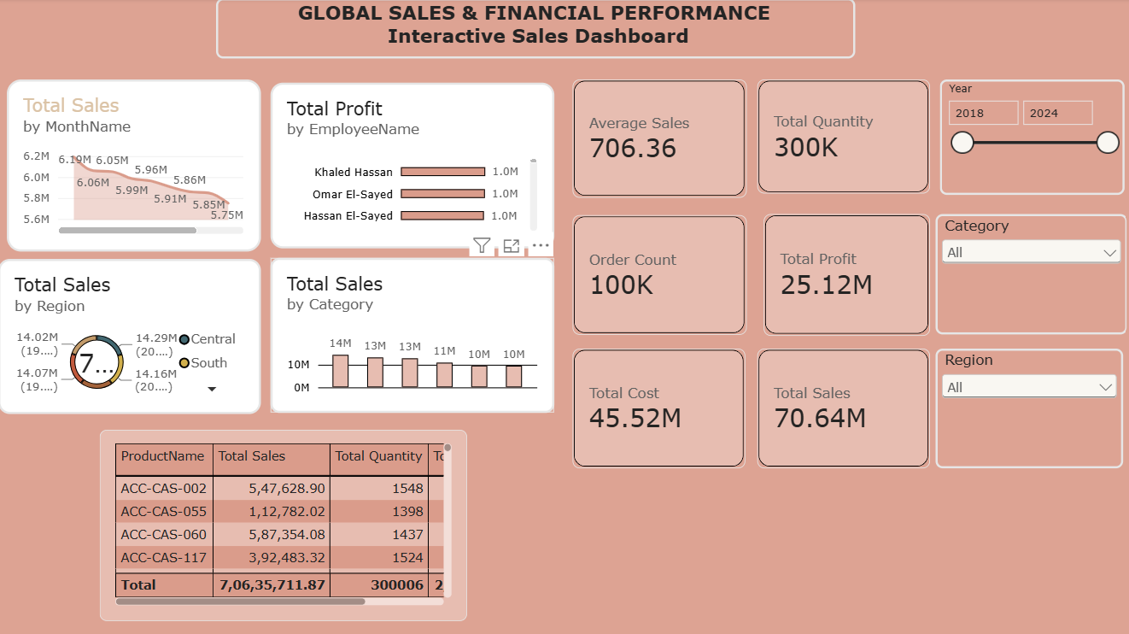
Figure 1: Global Sales & Financial Performance — Interactive Sales Dashboard
The dashboard consolidates the business's sales and financial performance into a single interactive view. It features summary KPI cards (Average Sales, Total Quantity, Order Count, Total Profit, Total Cost, and Total Sales), a monthly sales trend line, a regional sales donut chart, a category-wise sales bar chart, a profit-by-employee chart, and a detailed product-level table. Slicers for Year, Category, and Region allow the report to be filtered dynamically, enabling users to drill down from a company-wide view into specific time periods, product lines, or geographies.

3. KPI Analysis
The KPI cards summarize the overall health of the business across the full 2018–2024 period:
KPI | Value | Insight
Total Sales | ₹70.64M | The overall revenue generated across all regions, categories and years.
Total Profit | ₹25.12M | Profit margin of roughly 35.6% of total sales, indicating healthy overall profitability.
Total Cost | ₹45.52M | Cost of goods/operations consumes about 64% of revenue, the primary lever for margin improvement.
Total Quantity | 300K | Volume of units sold, reflecting strong transactional activity.
Order Count | 100K | Total number of orders processed, implying an average of 3 units per order.
Average Sales | 706.36 | Average revenue per order/line item, a useful benchmark for pricing and upsell strategies.
Together, these figures show a financially healthy operation: profit margins are solid, but with total cost nearly two-thirds of revenue, disciplined cost control remains the biggest opportunity to grow the bottom line without needing proportional growth in sales volume.

4. Product Category Performance Analysis
The “Total Sales by Category” chart breaks total revenue into six product categories, with values ranging from roughly ₹10M to ₹14M per category. The relatively even distribution (14M, 13M, 13M, 11M, 10M, 10M) suggests a well-diversified product portfolio rather than dependence on a single category.
The leading category contributes noticeably more than the lowest-performing category, a gap of roughly 4M, which highlights room to grow the underperforming categories through targeted merchandising, bundling, or promotional pricing. The accompanying product-level table (e.g., ACC-CAS-002, ACC-CAS-055, ACC-CAS-060, ACC-CAS-117) further shows meaningful variation in per-SKU sales and quantity, useful for identifying both star performers and long-tail products that may need review.

5. Monthly Sales Trend Analysis
The “Total Sales by MonthName” line chart shows sales gradually declining across the period shown, moving from a peak of approximately ₹6.19M down to about ₹5.75M. This downward slope, rather than sharp swings, suggests a gradual softening of demand rather than a single disruptive event.
This steady decline is an early warning signal worth monitoring closely: if it continues across subsequent months, it could point to seasonality, increased competition, or fading effectiveness of current marketing or pricing strategies. Cross-referencing this trend with the Year slicer (2018–2024) would help determine whether this is a recurring seasonal dip or a longer-term structural trend.

6. Regional Sales Analysis
The regional donut chart divides total sales across regions including Central and South, alongside other regions, each contributing roughly ₹14M – ₹14.3M and between 19% and 20% of total sales. This near-equal split across regions indicates a well-balanced geographic footprint with no single region dominating overall performance.
While balance reduces geographic risk, it also means no single region is currently acting as a standout growth engine. The narrow 19–20% band across regions suggests that with focused investment, one or two regions could be pushed ahead of the pack to become clear growth leaders.

7. Employee Performance Analysis
The “Total Profit by EmployeeName” chart highlights the top contributing employees — Khaled Hassan, Omar El-Sayed, and Hassan El-Sayed — each generating approximately ₹1.0M in profit. Their closely matched contributions suggest a consistent, well-trained top-performing group rather than reliance on one standout individual.
Since the chart displays only the leading employees, it would be valuable to compare this top tier against the full sales team to identify performance gaps, replicate best practices from top performers, and design targeted coaching or incentive programs for employees below this benchmark.

8. Business Recommendations
Inventory Planning
- Align stock levels with the category sales distribution — prioritize inventory for the top categories (~14M in sales) while trimming overstock risk on the lowest-performing categories (~10M).
- Use the declining monthly sales trend to build more conservative demand forecasts for upcoming periods and avoid overstocking.
Marketing Strategy
- Investigate the cause of the gradual month-over-month sales decline and launch targeted campaigns or promotions to reverse the trend before it compounds.
- Run category-specific promotions for the two lowest-performing categories to close the gap with top performers.
Regional Expansion
- Since all regions perform within a tight 19–20% band, invest additional marketing and distribution resources in one or two regions to convert them into clear growth leaders.
- Evaluate underlying regional cost structures, since evenly split revenue does not guarantee evenly split profitability.
Employee Performance
- Formalize a mentorship program pairing top performers (Khaled Hassan, Omar El-Sayed, Hassan El-Sayed) with lower-performing team members to raise average profit per employee.
- Introduce performance-based incentives tied to profit contribution rather than sales volume alone, to reinforce margin-conscious selling.
Product Portfolio
- Conduct a deeper SKU-level review (as seen in the product table) to identify consistently low sales/quantity products that may be candidates for discontinuation or repositioning.
- Bundle high-margin, lower-visibility products with best-selling categories to increase their exposure.
Customer Targeting
- Use the Average Sales value (₹706.36 per order) as a benchmark to design upsell and cross-sell offers that lift average order value.
- Segment customers by region and category preference to deliver more personalized offers, leveraging the balanced regional and category data already captured in the dashboard.

Conclusion
Overall, the Global Sales & Financial Performance dataset reflects a diversified, profitable, and geographically balanced business. The primary areas of concern — the gradual decline in monthly sales and the relatively high cost-to-revenue ratio — are also the clearest opportunities for improvement. By acting on the recommendations above, the business can convert its stable foundation into renewed growth across categories, regions, and its workforce.

